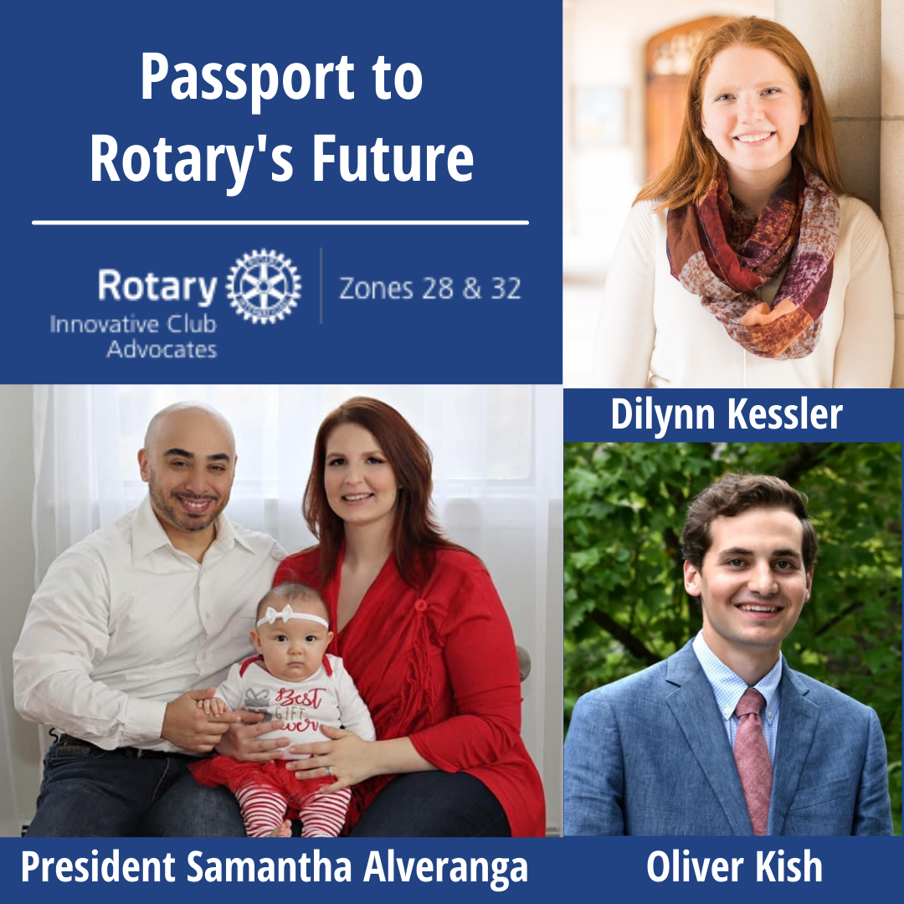

By Cecily Smith, Innovative Club Advocate, Zone 32 ARC, RC Metro NYC
District 7210 in NY just chartered a new Rotary Club - a Passport Club created with innovation at its core, to allow its members to be a part of the Rotary family IN WAYS THAT WORK FOR THEM! And with two second generation Rotarians, two Rotarian transfers, and eight former Rotarians, it offers ways for a range of people to be active in Rotary. We talked to some of the those involved:
President Samantha Alveranga (a part of the Rotary Young Professionals Summit @ Bear Mtn and previously a Rotarian in another 7210 club):
“As a new wife and mother, who recently just began her adult ‘career’, I definitely had one foot out the door when it came to Rotary. I still attended events but was missing both club and committee meetings and was feeling guilty about not being able to commit as fully as I wanted to. Then when Larry Palant approached me about being a part of the Passport Club, I thought it was something that could definitely fit into my schedule. However, I must have missed a meeting because now I’m the president of the club!
Our club is made up of people, who for one reason or another, whether it be hectic school schedules, family life, or involvement in other community service programs, come together as Rotarians to serve our communities as best we can. Our meetings are less frequent, our dues are lower, and we only meet on zoom. This does not take away from our ability to serve. We are working on mentor programs; financial literacy programs and our education committee even has a crazy notion to build a school in Africa that may just become a reality.”
According to DMC and DGN Larry Palant: “Prior to the Pandemic our intent was to operate the Passport Club as a service-based club with the requirement of 16 hours per quarter of service by each member. In-person meetings would be quarterly, and members would be encouraged to attend other clubs’ weekly meetings. Covid-19 changed all that. Our members are still required to have the service aspect; however, it's not limited to Rotary only. Any service that a member might perform such as Board meetings, Meals-on-Wheels, faith-based, soup kitchens, etc. with other organizations that our members might be affiliated with (as we all know Rotary is usually just one of the organizations that our members are involved with) counts towards the service hours requirement. Chartering took some time. We did mass emails to former Rotarians. These lists were available on our District management system (ClubRunner). Once we started receiving replies we would reach out to the individuals and "convince" it was a good idea for returning to Rotary.”
An innovative club model like this attracted two young second generation Rotarians, who on their own decided to join 7210 Passport. Says Dilynn Kessler (daughter of upcoming RID Drew Kessler), “Rotary has been a big part of my life ever since I can remember. Both of my parents are Rotarians, and I was fortunate enough to grow up surrounded by amazing people in this organization and attend Rotary events that inspired me. I always knew that when the time came, I too would join Rotary and have the opportunity to be one of those people that gave back and inspired others. When I heard about the passport club, I decided that it was the right time to join and I knew being part of the passport club would be an amazing opportunity because I would be able to do good and engage with fellow Rotarians through District 7210 even though I am currently away at school. “
And Oliver Kish (son of PDG Cindie Kish) felt that “Coming out of college I knew I wanted to be involved with service and the passport club allowed me to join Rotary without the commitments of a normal club that would have been an issue due to my busy schedule.”
Freedom +Flexibility + Financially Accessible = A great start to this new club!
If you want to learn more about Passport clubs, and starting one in your district, please join the ICA team on Tuesday, March 16th @ 7pm ET for a 30-minute talk about Passports & Flexibility.


